NCTA Summer Meeting 2022 - July 14th-16th 2022
Plan your Vacation today!
www.christmastreeforum.com/ncta-meeting/ www.novascotia.com
Book early for best selection & prices. Deadline: June 9th, 2022
CTCNS has blocked rooms, and will be hosting most of the events at the World Famous:
Home of ‘The Curse of Oak Island’ CAD $175-$225/night+ 15% HST 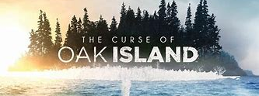
To make reservations Contact Oak Island Resort at 1-800-565-5075. For group rate, make sure the reservation is made under the Christmas Tree Council of Nova Scotia Meeting room block. Rates will also remain available for any guests wishing to stay up to 3 days prior or 3 days post event/meeting, based on availability.
CTCNS has also blocked rooms at the following hotels:
- Best Western Plus Bridgewater- www.bestwestern.com 1(800) 780-7234
CAD $169/night + 15% HST
For group rates, make sure the reservation is made under the Christmas Tree Council of Nova Scotia Meeting room block.

- Mecklenburgh Inn-www.mecklenburghinn.ca – Chester, NS Tel: 902-275-4638
CAD $169-195/night + 15% HST, including breakfast

- Atlantic View Motel & Cottages - www.atlanticviewmotel.ca – Lunenburg, NS Tel: 902-634-4545
Rooms CAD $119-159/night + 15% HST Cottages CAD $145-179/night + 15% HST

- Airbnb: Vacation Rentals, Cabins, Beach Houses, Unique Homes & Experiences

Airport Details: Halifax Stanfield International Airport located in Enfield NS https://halifaxstanfield.ca/
Distance: 1 hour 5 minutes to Oak Island Resort
1 hour 19 minutes to Best Western Plus Bridgewater

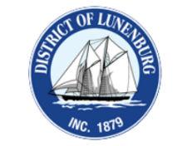
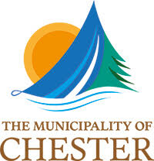
Car Rentals: Car Rentals - Halifax Stanfield International Airport https://halifaxstanfield.ca/transportation/car-rentals/

